***LAB MANUAL # 4:***

***Roll_no 068464***

***Submitted _by Nabila Naz***

***Submitted To Sir Kamran .***

***Bs (IT) 5th(sem) Morning***

**CC-311 Operating Systems LAB**

Practice Program on fork() system call

Q1**. Write a program using fork() system call to create two child of the same process i.e., Parent P having child process P1 and P**

**Figure1.1**

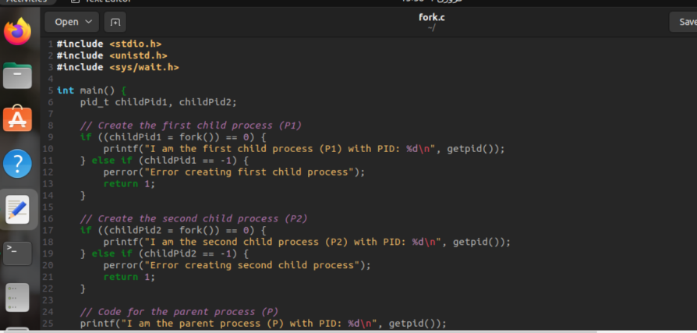

**Figure1.2**

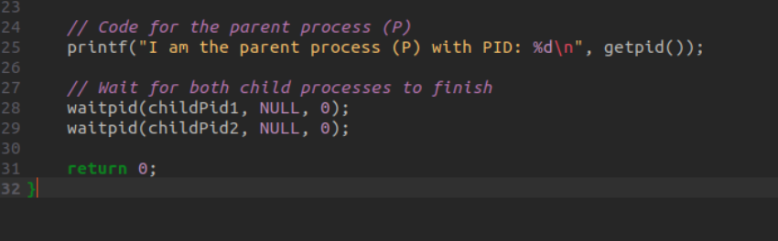

**Compilation:**

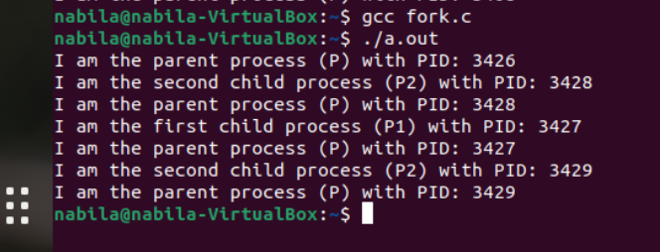

Q2. **Write a program using fork() system call to create a hierarchy of 3 process such that P2 is the child of P1 and P1 is the child of P.**

**Figure1.1**

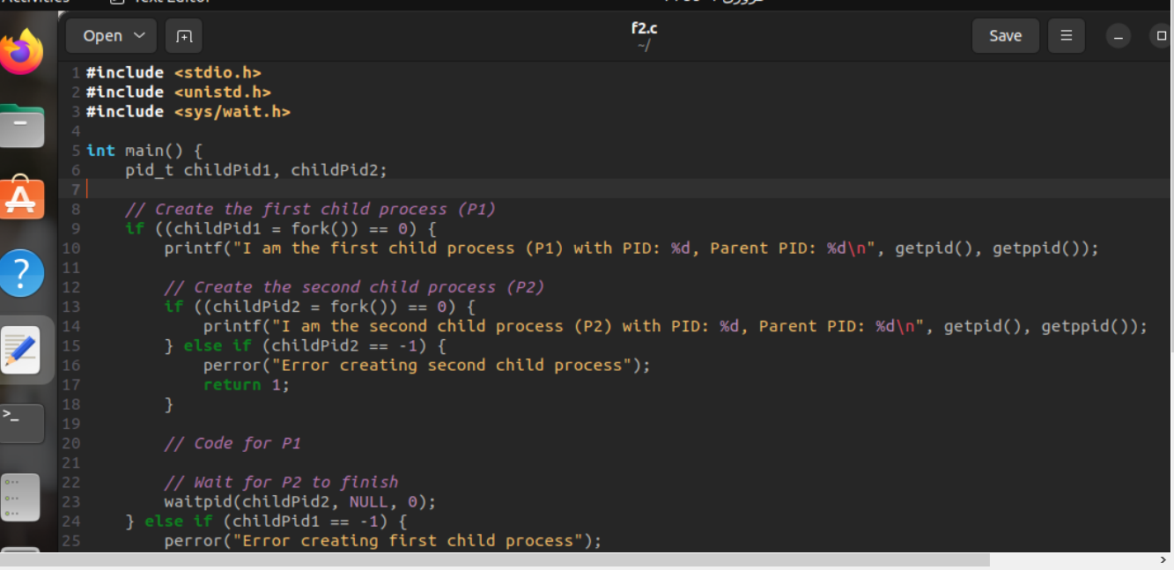

**Figure1.2**

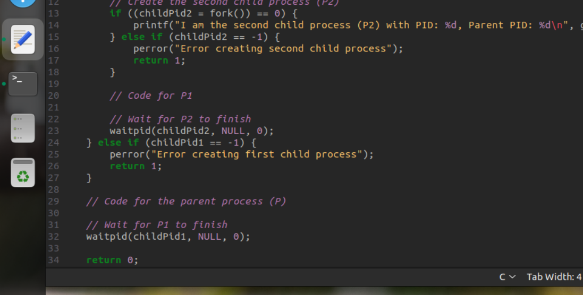

**Compilation:**

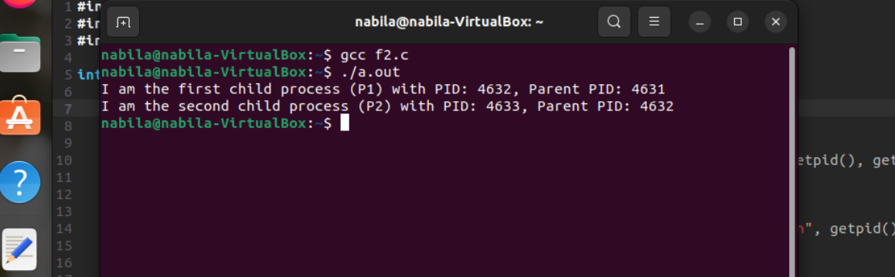

*Viva questions on fork() system call*

**Q1. What does the fork() system call return on success?**

* The **Fork()** system call returns the child process's PID (Process ID) to the parent process and 0 to the child process. It returns -1 in case of failure.

**Q2. What is the PID of the child process?**

* In the child process, the **Fork()** system call returns 0. Therefore, the PID of the child process can be obtained using **getpid().**

**Q3. Which function is used to get the PID of a process?**

* The **getpid()** function is used to get the PID (Process ID) of a process. It is part of the <**unistd.h>**header in C.

**Q4. How many total process are created with the below code**

**int main()**

**{**

**fork();**

**fork();**

**}**

* The **Fork()** system call is used twice in the code. Each **Fork()** creates a new process. Therefore, the total number of processes created is **2 * 2 = 4.**

**-------------------------------------------------------------------------------------**